Department Consolidation Report (DCR)
Department: Prerna (UPSRLM)
Figment: Lakhpati Didi Initiative (DAY-NRLM)

Scope: LDCMS (Pragati Setu) Figment Code: F-10A1
Dated: 17-12-2025
S.No. | Authors | Designation | Auth Group | Contact
1 | Ayush M Srivastava | Software Developer | BDO Development Team | ayush.msrivastava@gmail.com

Table of Contents
S.No. | Title | Page No.
1 | Purpose | 3
2 | Concept and Definition | 3
3 | Implementation Strategy | 3
4 | Financial Support Mechanisms | 4
5 | Livelihood Diversification and Cluster Approach | 5
6 | Digital Aajeevika Register | 6
7 | Monitoring, Evaluation and Learning (MEL) | 6
8 | Community Cadre and Capacity Building | 6
9 | Training and Deployment Protocol | 7
10 | Government Convergence and Partnerships | 8
11 | Key National and Regional Events and Updates | 8
12 | Targets and Coverage | 9
13 | Challenges and Constraints | 9
14 | Summary | 10
15 | Metric Consolidations (Operational Architecture) | 11-15
16 | UP Program Scale | 11
17 | DAR Data Management Requirements | 12
18 | Stakeholder Management and Institutional Hierarchy | 13
19 | Mandatory Departmental Convergence | 14

Purpose
The document provides a comprehensive overview of the "Lakhpati Didi" initiative under the Deendayal Antyodaya Yojana - National Rural Livelihood Mission (DAY-NRLM), aimed at empowering women Self-Help Group (SHG) members in rural India to achieve an annual household income of Rs. 1,00,000 or more through diversified and sustainable livelihood activities.

1. Concept and Definition
- Lakhpati Didi: A SHG member whose household sustains an annual income of Rs. 1,00,000+ over at least four agricultural seasons or business cycles, averaging Rs. 10,000+ monthly.
- Focus is on transformation through sustainable livelihood practices (farm, non-farm, service), resource management, and improved living standards.
- SHGs act as platforms for collective action, financial literacy, skill development, and livelihood assistance.
- The initiative moves beyond social and financial inclusion to entrepreneurial empowerment.

2. Implementation Strategy
- Identification of Potential Lakhpati Didis: Criteria include SHG members with at least two years in the group, beneficiaries of livelihood interventions (SHG members who have already received support (training, assets, credit, technical assistance or other program inputs) under government/mission programmes, especially SHG CIF FUND), and practicing multiple livelihood activities.
- Equal opportunity across social and economic categories is emphasized, with about 25% targeted from households earning over Rs. 1 lakh and 75% below that threshold.
- States/UTs have flexibility to define additional criteria.
- Capacity Building and Training:
  - Creation of Master Trainers and Community Resource Persons (CRPs).
  - Cascading training model: National Resource Persons (NRPs) train Master Trainers → Master Trainers train CRPs → CRPs handhold Lakhpati Didis.
  - Training covers livelihood planning, digital tools, livelihood models, and handholding roles.
  - Training modules and resources are available online.
- Livelihood Planning and Support:
  - Use of digital tools for livelihood planning and monitoring.
  - Development of product/service clusters and value chain interventions.
  - Establishing linkages with government schemes, private sector, and markets.
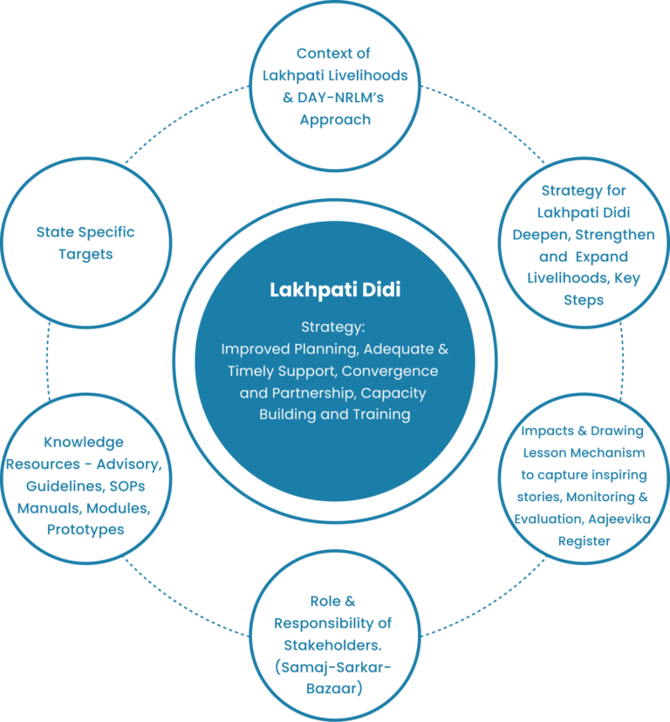

3. Financial Support Mechanisms
- Capitalization Support:
  - Revolving Fund (RF): Rs. 20,000-30,000 per SHG to enable internal lending.
  - Community Investment Fund (CIF): Up to Rs. 2.5 lakh per SHG for socio-economic activities.
  - Vulnerability Reduction Fund (VRF): Rs. 1.5 lakh per Village Organization for addressing vulnerabilities.
  - Viability Gap Fund (VGF): Support for Cluster Level Federations (CLFs) to bridge operational cost gaps.
- Bank Linkage:
  - Collateral-free loans up to Rs. 20 lakh per SHG.
  - Interest subvention on loans up to Rs. 3 lakh at 7%.
  - Overdraft facility of Rs. 5,000 for Jan-Dhan account holders.
- Women Enterprise Acceleration Fund:
  - Credit guarantee for loans up to Rs. 5 lakh (max 5 years).
  - Interest subvention for loans up to Rs. 1.5 lakh (max 3 years).
  - Collateral support up to 50% (or Rs. 2 crore) for enterprise collectives/FPOs.
  - Incentives for women collectives.
- Support to Producer Groups (PGs), Producer Enterprises (PEs), and Farmer Producer Organizations (FPOs):
  - Rs. 2 lakh per PG for working capital and infrastructure.
  - Rs. 15 lakh equity grant to FPOs over 3 years.
  - Promotion of large producer enterprises and federations.
- Other Schemes:
  - Start-Up Village Entrepreneurship Programme (SVEP): Rs. 6.5 crore per block to support rural enterprises.
  - One Stop Facility (OSF): Business facilitation at block level with finance support.
  - Micro Enterprise Development (MED): Support for non-farm enterprises with handholding and financing.
  - Incubators: Piloting support for scaling women-led enterprises.

4. Livelihood Diversification and Cluster Approach
- Promotion of farm and non-farm livelihoods through integrated farming clusters (IFCs), artisan and sectoral clusters.
- Soft interventions: design, quality assurance, enterprise creation, market development, financing, technology upgradation, skilling.
- Hard interventions: Common Facility Centers (CFCs), Common Production Centers (CPCs).
- Rs. 5 crore provided per cluster for setup and operations.
- Leveraging convergence with schemes like SFURTI and Development Commissioners for Handicrafts and Handloom.

5. Digital Aajeevika Register
- A digital tool maintained at Village Organization (VO) level to track livelihood activities and income every six months.
- Captures data on loans, income from agriculture, livestock, non-timber forest produce, business, salary, commissions, remittances, and other sources.
- Enables monitoring, planning, and measuring progress of Lakhpati Didis.
- Data collection involves training of staff and e-CRPs, periodic monitoring, and third-party evaluations for authenticity.
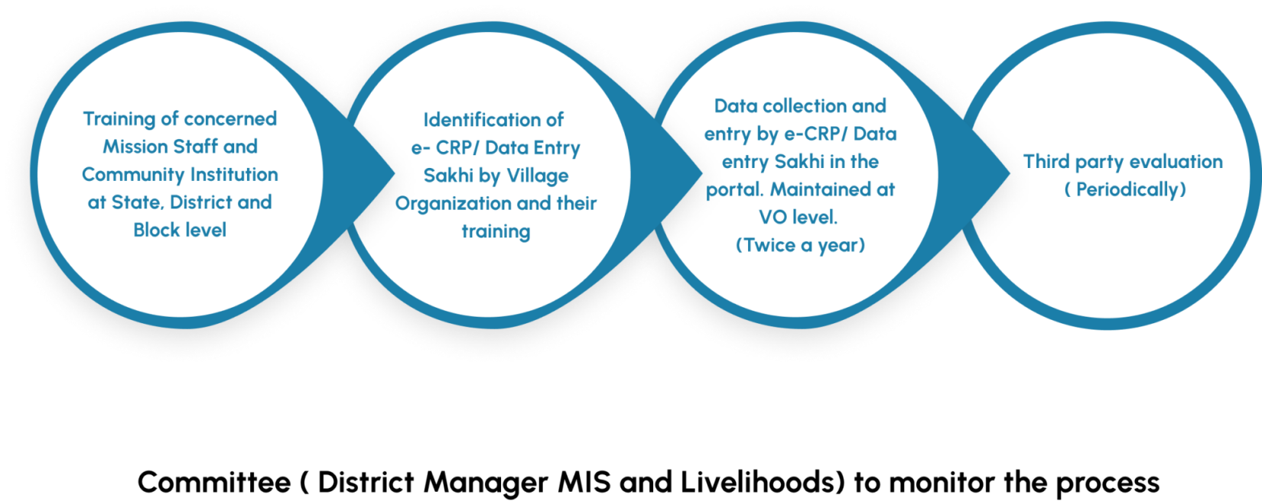

6. Monitoring, Evaluation, and Learning (MEL)
- Steering Committees at National, State, District, and Block levels oversee convergence, partnerships, and progress.
- Livelihood Sub Committees at community level facilitate planning, implementation, entitlement access, financing, and market linkages.
- Periodic reviews based on Key Performance Indicators (KPIs).
- Exposure visits and peer learning promote knowledge sharing.
- Third-party evaluations ensure data authenticity and impact assessment.

7. Community Cadre and Capacity Building
- Community Resource Persons (CRPs):
  - Women from the community trained as para-professionals for institution building, financial inclusion, livelihoods, and social development.
  - Over 5 lakh CRPs deployed nationally.
  - CRPs provide training, handholding, and extension services.

- Master CRPs (Agro-Ecological Practices):
  - Experienced CRPs trained and empaneled nationally to provide advanced training and on-field support.
  - Engage in training Krishi Sakhis (internal CRPs), organizing Farmer Field Schools, demonstrations, and establishing Non-Pesticide Management (NPM) shops and Custom Hiring Centres (CHCs).
  - Deployment for 91 days/year with six rounds aligned to cropping seasons.
  - Selection based on experience, education, attitude, and training performance.
  - Continuous skill upgradation through refresher trainings and evaluations.
- Professional Resource Persons (PRPs):
  - Graduate professionals stationed at block level to support farm livelihoods, mentor CRPs and Master CRPs, coordinate with departments, and ensure fund utilization.
- Internal CRPs (Krishi Sakhi):
  - Active women farmers implementing agro-ecological practices, supporting Master CRPs, participating in trainings, and promoting nutritional gardens.

8. Training and Deployment Protocol
- Structured 9-day training modules for Master CRPs covering theory and practical inputs on agro-ecological practices.
- Briefing and debriefing meetings before and after each CRP round.
- Deployment coordinated via MoUs between Resource and User State Rural Livelihood Missions (SRLMs).
- Monitoring and review by Block Managers, District Managers, and State units.
- Honorarium and allowances defined for Master CRPs and PRPs.

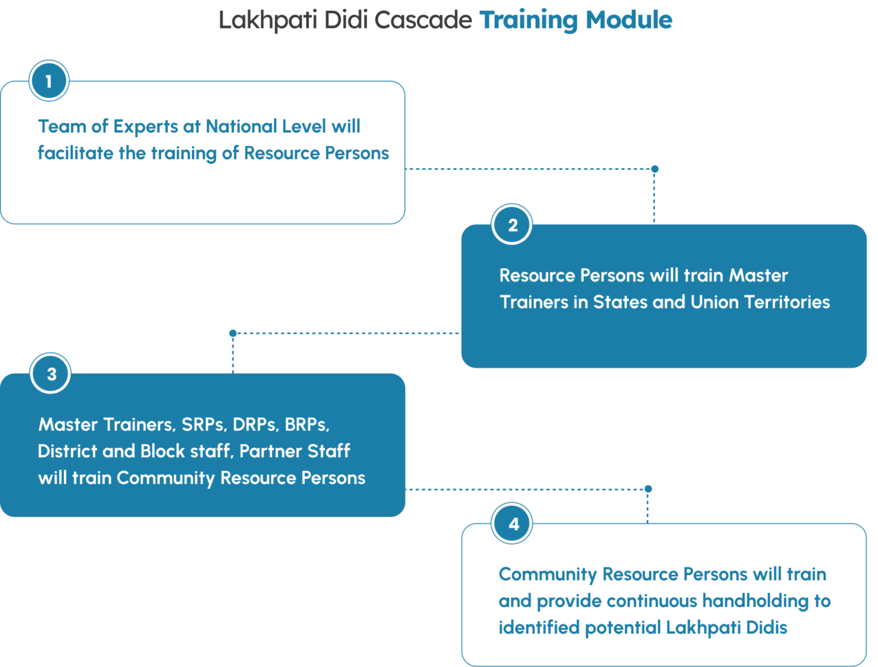

9. Government Convergence and Partnerships
- Strong convergence with multiple Ministries and Departments for technical, financial, and capacity-building support:
  - Ministry of Rural Development (MGNREGS, DDU-GKY, RSETIs, PMAY-G)
  - Ministry of Agriculture & Farmers Welfare (MIDH, SMAM, National Bamboo Mission, PMKSY, FPO schemes)
  - Department of Animal Husbandry and Dairying (National Livestock Mission, Rastriya Gokul Mission)
  - Ministry of Food Processing Industries (PMFME)
  - Department of Fisheries (PM Matsya Sampada Yojana)
  - Ministry of MSME (SFURTI)
- Partnerships with Civil Society Organizations, Private Sector, Technical Support Agencies, and Start-ups.
- National, State, District, and Block level steering and convergence committees ensure coordinated implementation.

10. Key National and Regional Events and Updates
- Numerous workshops, webinars, conclaves, and training sessions conducted nationally and regionally from 2023 to 2025 focusing on:
  - Agriculture and Livestock Entrepreneurship
  - Market linkages for rural women producers
  - Gender mainstreaming and empowerment
  - Climate change adaptation in rural livelihoods
  - Integrated Farming Clusters (IFCs)
  - Livestock and animal husbandry schemes
  - Promotion of specific subsectors like millets, bamboo, spices, aquatic livelihoods
- Launch of Lakhpati Didi web portal and digital tools.
- High-level government involvement including Prime Minister and President in events promoting Lakhpati Didis.

11. Targets and Coverage
- Ambitious goal: Enable 2 crore Lakhpati Didis in rural India.
- Current coverage includes:
  - Nearly 10 crore women in SHGs.
  - 87.39 lakh SHGs.
  - Rs. 33,497 crore capitalization support.
  - Rs. 6.95 lakh crore bank credit linkage since 2013-14.
- State-wise targets for FY 2023-24, with Uttar Pradesh targeting nearly 29 lakh Lakhpati Didis.
- Detailed district/block level data for Uttar Pradesh including numbers of Master Trainers, CRPs, Potential Lakhpati Didis (PLDs), Digital Aajeevika Registers (DARs), and Lakhpati Didis (LDs).

12. Challenges and Constraints
- Need for adequate skilled human resources at all levels.
- Timely release of funds from treasury to implementing agencies.
- Continuity in leadership at State Mission Director and CEO levels.
- Leveraging private sector, civil society, and start-ups effectively.
- Adoption of innovative financing models (crowdfunding, sweat equity, hybrid funding).
- Ensuring consistent, process-driven interventions for sustainable impact.

13. Summary
The Lakhpati Didi initiative under DAY-NRLM is a multi-faceted, large-scale government program aimed at empowering rural women SHG members by enabling them to achieve sustainable livelihoods with an annual income of Rs. 1 lakh or more. The strategy involves:
- Identification and capacity building of Master Trainers, CRPs, and potential Lakhpati Didis.
- Diverse livelihood promotion across farm, non-farm, and service sectors.
- Robust financial support and credit linkage mechanisms.
- Digital tools for livelihood planning and income tracking.
- Convergence with multiple government schemes and partnerships.
- Structured training and deployment of community cadres (Master CRPs, PRPs, i-CRPs).
- Regular monitoring, evaluation, exposure visits, and peer learning.
- National and state-level coordination with clear targets and timelines.
This initiative reflects a whole-of-government approach to rural prosperity, leveraging institutional strength, technology, financial inclusion, and community empowerment to transform rural households economically. This consolidation report details the necessary departmental and programmatic linkages essential for developing a specialized software management system aimed at accelerating the Lakhpati Didi Conversion process in Uttar Pradesh (UP).
The software must integrate the operational architecture of the Deendayal Antyodaya Yojana-National Rural Livelihoods Mission (DAY-NRLM), which governs the Lakhpati Didi Initiative (LDI), with various central and state government schemes (convergence) to ensure holistic support and rigorous, data-driven tracking.

14. Metric Consolidations (Operational Architecture)
I. Uttar Pradesh Context and Program Scale
The software must manage the substantial scale of the LDI within UP, utilizing the existing grassroots infrastructure.
Parameter | Metric/Target (Uttar Pradesh)
Nodal Ministry | Ministry of Rural Development (MoRD) / DAY-NRLM
Lakhpati Didi (LD) Target (2024-25) | 28.92 Lakh households
Lakhpati Didis Achieved (Self-Reported) | 11,15,982 women (as of mid-2025)
Potential Lakhpati Didis (PLDs) Identified | 35,90,370 households
Community Resource Persons (CRPs) | 52,621 deployed
Digital Aajeevika Registers (DARs) | 58,11,452 records created
Central Allocation (NRLM, FY 2025-26) | ₹243,100.19 Lakh
SHG Network (LokOS Outreach) | 8,90,472 SHGs, 62,197 Village Organizations (VOs), 3,255 Cluster Level Federations (CLFs)

II. Core Data Management Requirements (DAR Integration)
The software must leverage and extend the functionality of the Digital Aajeevika Register (DAR), which is the foundational digital tool for tracking income and livelihood data.
Functionality | Data Point Required for Tracking | LDI Sustainability Criterion
Outcome Validation | Annual household income > Rs 1,00,000. | Income must be sustained for a minimum of four agricultural seasons and/or business cycles (average monthly income Rs 10,000).
Income Diversification Tracking (DAR) | Net income from four categories: 1. Agriculture & Allied Activities (livestock, fisheries, NTFP); 2. Manufacturing/Trading/Services Enterprises; 3. Honorarium/Salary; 4. Other sources (remittances, commissions, government schemes). | The software must track data collection by Livelihood e-CRPs/Data entry Sakhis and ensure updates occur every six months (after crop harvesting or business cycle completion).
Enterprise Support Tracking | Capitalization support received (RF/CIF/VRF/WEAF), Bank Linkage status. | Must track collateral-free bank loans up to Rs 20 Lakh availed by the SHG.
Human Resource Monitoring | Tracking the activities, service delivery (training, hand-holding), and geographical mapping of the 52,621 CRPs in UP, often referred to as "feet on the ground". | Each CRP is responsible for training and hand-holding 50-75 identified SHG members.

III. Stakeholder Management and Institutional Hierarchy
The software must reflect the multi-tiered institutional structure mandated by DAY-NRLM, where community institutions spearhead implementation, planning, and monitoring, even though the focus is on the individual SHG woman.
Institutional Level | Role (Software Functionality) | UP Count
National/State Mission (NMMU/SRLM) | Setting annual targets (e.g., UP's 28.92 Lakh), conducting high-level quarterly performance reviews, coordinating convergence efforts, and training Master Trainers. | NRLM Central Allocation: ₹243,100.19 Lakh
Cluster Level Federation (CLF) | Anchor the entire process, manage internal financial mechanisms, supervise monitoring, facilitate institutional strengthening and convergence. | 3,255 CLFs
Village Organization (VO) | Manage Revolving Funds (RF) and Vulnerability Reduction Funds (VRF, Rs 1,50,000 per VO). They prepare Village Prosperity and Resilience Plans (VPRP). | 62,197 VOs
Self-Help Group (SHG) | Base unit for savings, internal lending (RF: Rs 20,000–Rs 30,000 per group), and accessing external credit (Collateral-free loans up to Rs 20 Lakh). | 8,90,472 SHGs
Community Resource Persons (CRPs) | Ground-level execution, using digital tools to prepare Livelihood Plans, conducting hand-holding, and supporting access to credit and insurance. | 52,621 CRPs

IV. Mandatory Departmental Consolidation (Convergence)
The success of the LDI in UP relies on convergence (Strategy-3), meaning the software must track the seamless linkage between the Lakhpati Didi/SHG and external departmental schemes.
Ministry/Department (Domain) | Scheme/Resource to be Integrated/Tracked | Purpose for Lakhpati Didi
Ministry of Finance (Credit Access) | Pradhan Mantri MUDRA Yojana (PMMY); Bank Linkage; Women Enterprise Acceleration Fund (WEAF). | Facilitating subsidized or collateral-free loans for enterprises (up to Rs 20 Lakh for SHGs; Credit Guarantee up to Rs 5 Lakh for individuals under WEAF).
Ministry of Skill Development & Entrepreneurship (MSDE) (Skill & Capacity) | Pradhan Mantri Kaushal Vikas Yojana (PMKVY); RSETIs. | Providing customized training and formal certification in various trades (e.g., tailoring, animal husbandry, food processing) and promoting self-employment.
Ministry of MSME (Industry & Clusters) | Scheme of Fund for Regeneration of Traditional Industries (SFURTI). | Leveraging funds (Rs 5 Crore per cluster) and technical assistance for Artisan clusters and Sectoral clusters (handlooms, handicrafts, food service) to achieve economies of scale and high-value product development.
Ministry of Agriculture & Farmers' Welfare (MoA&FW) (Farm Sector) | 10K Farmer Producer Organizations (FPO) Scheme; PM Krishi Sinchayi Yojana (PMKSY); Agri Infra Fund (AIF); National Bamboo Mission. | Providing infrastructure, equity grants (Rs 15 Lakh per FPO), and technology for agriculture, horticulture, and Integrated Farming Clusters (IFCs).
Department of Animal Husbandry & Dairying (DAHD) (Allied Sector) | Accredited Agent for Health and Extension of Livestock Production (A-HELP); National Livestock Mission. | Supporting the majority of SHG households dependent on allied activities (dairy, goat/sheep rearing, poultry).
Private Sector/E-commerce (Market Access) | Partnerships with Flipkart, Amazon, Meesho, Jiomart, and the dedicated e-SARAS platform. | Enabling market access, branding, packaging, and e-commerce for products generated by SHG members.
Insurance/Social Security | Pradhan Mantri Jeevan Jyoti Bima Yojana (PMJJBY); Pradhan Mantri Suraksha Bima Yojana (PMSBY); Atal Pension Yojana (APY). | CRPs are expected to facilitate insurance support (Life and Health) and pension enrollment for Lakhpati Didis and their activities to mitigate risks and ensure stability.
The software for Uttar Pradesh must be fundamentally a monitoring, guidance, and auditing tool that ensures the achievement of the sustained income threshold across the specified four business cycles, integrating financial data gathered by the large network of 52,621 CRPs with the implementation support provided by these converging departments.

